**ELEMENTS OF POWER SYSTEMS**

**TUTORIAL 1**

**QUES 1(a).**

x=[1 2 3 4]

RMS = sqrt(mean(x.^2)) %applying formula for rms value

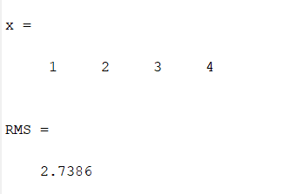

**QUES 1(b).**

x=0:0.1:10;

y=sin(x);

plot(x,y); %to plot graph



**QUES 2.**

a = [3,7,-1.5;0,3.2,1;0.11,-12,0];

b=[9 2 0];

x=b/a; %solution of linear equation in 3 variables

x

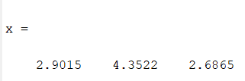

**QUES 3.**

x = 0:0.1:2*pi;

p=sin(x);

q=cos(x);

figure

p=plot(x,p,x,q); %to plot graph

p(1).LineWidth=5;

p(2).LineWidth=1;

xlabel('x values'); %labelling x axis

ylabel('p and q values'); % labelling y axis

title('First Graph'); %titling the graph

legend('p data','q data'); %to provide index

grid on; %display in grid mode



**QUES 4.**

z=5-3i;

Mag=abs(z) %gives magnitude of complex number

Angle=angle(z) %gives angle

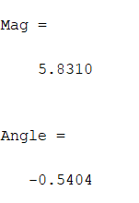

**QUES 5.**

v = ((5+9i)*(7+i))/(3-2i)

r =real(v) %gives real part

im =imag(v) %gives angle of complex number

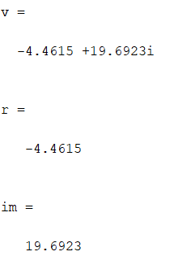

**QUES 6.**

%A=5*(s^2)+3*s+2

p=[5 3 2];

s=roots(p) %gives the roots of the equation

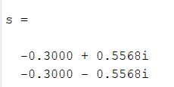

**QUES 7.**

a=5;x=2;y=8; %initialised the variables

f=exp(-a)*sin(x)+ 10*sqrt(y) %defined the expression

%additional problem

b=1:5;p=rand(1,5);q=randi(5,1,5); %initialised the variables

w=exp(-b).*sin(p)+10*sqrt(q) %defined the expression

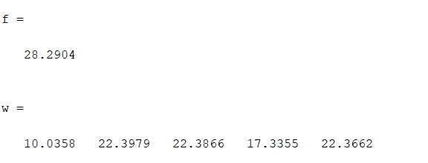

**QUES 8.**

i=0:2:10; %current value increased from 0 to 10 A

r=10; %resistance of 10 ohms

i %current printed

v=i*r %according to ohm's law, voltage id linear multiplication of current and resistance

p=(i.^2)*r %power dissipated

